Model-View-Controller (MVC) Model

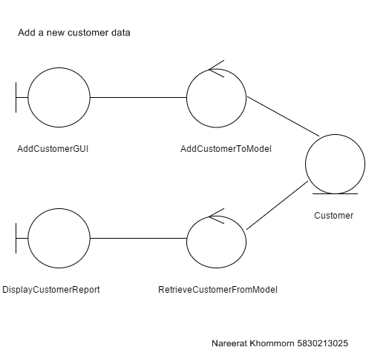

Sequence Diagram demonstrating operation “Add a new customer data”

